Surrogate key

Surrogate key used when there is no primary key in the column

Surrogate key generated the nos after consecutive squences

1. Go to adf
2. Go to dataflow
3. Create source

Add dataset

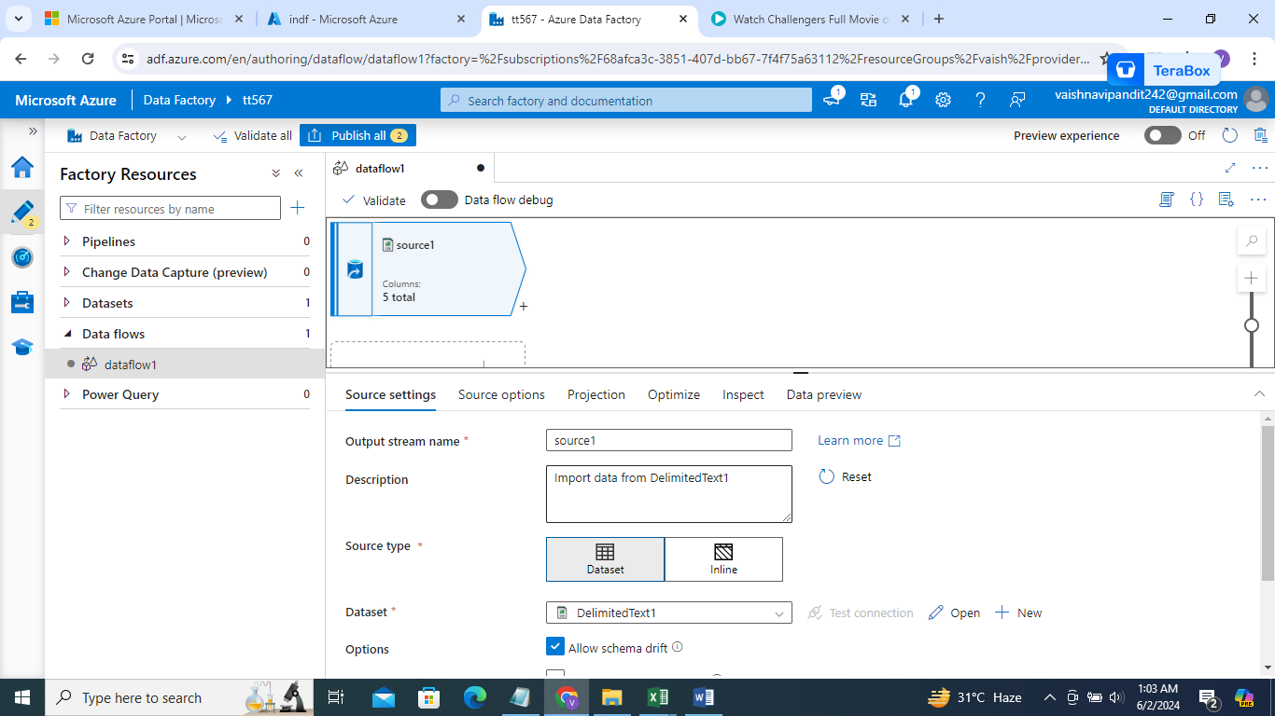

1. Click on + select surrogate key

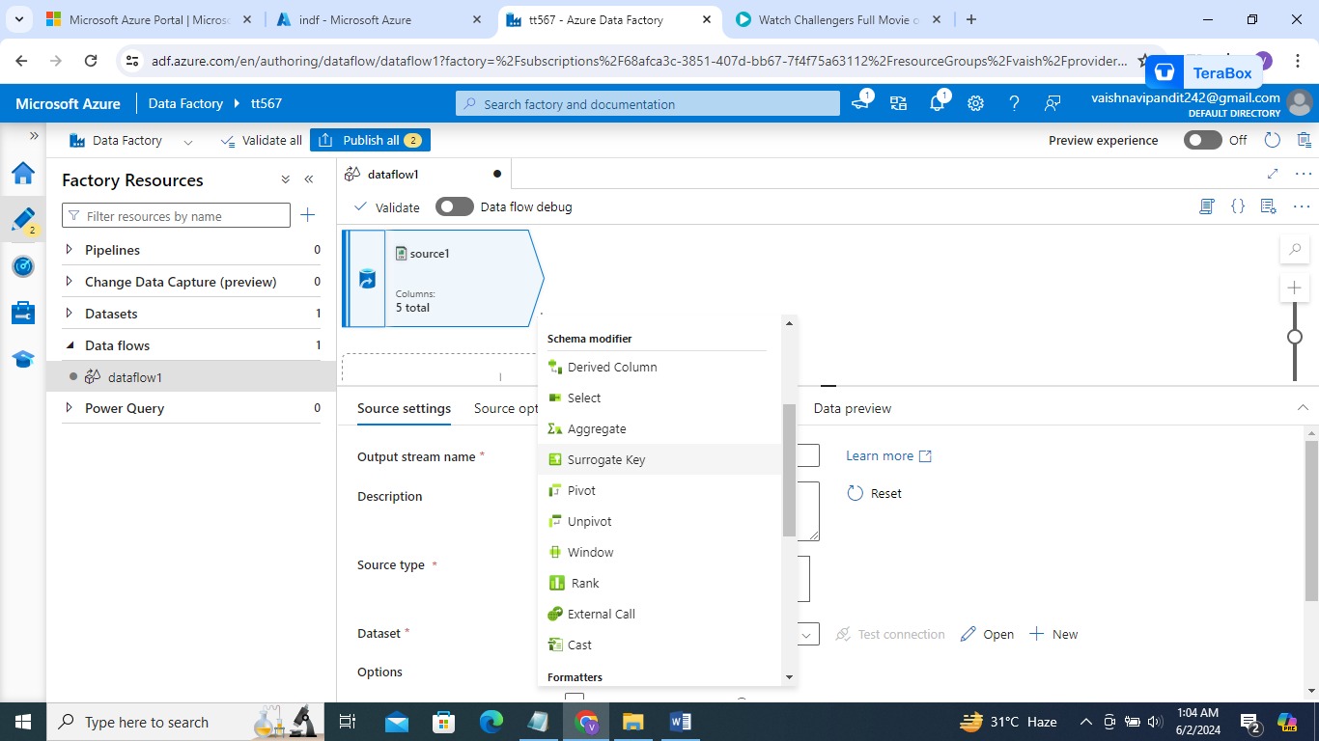

1. Now go to surrogate key

Add key column name as key

Start value as 100

Step value=1/2 if 1 it will generate 101,,102,103…

If 2 it will generate 102,104,106…

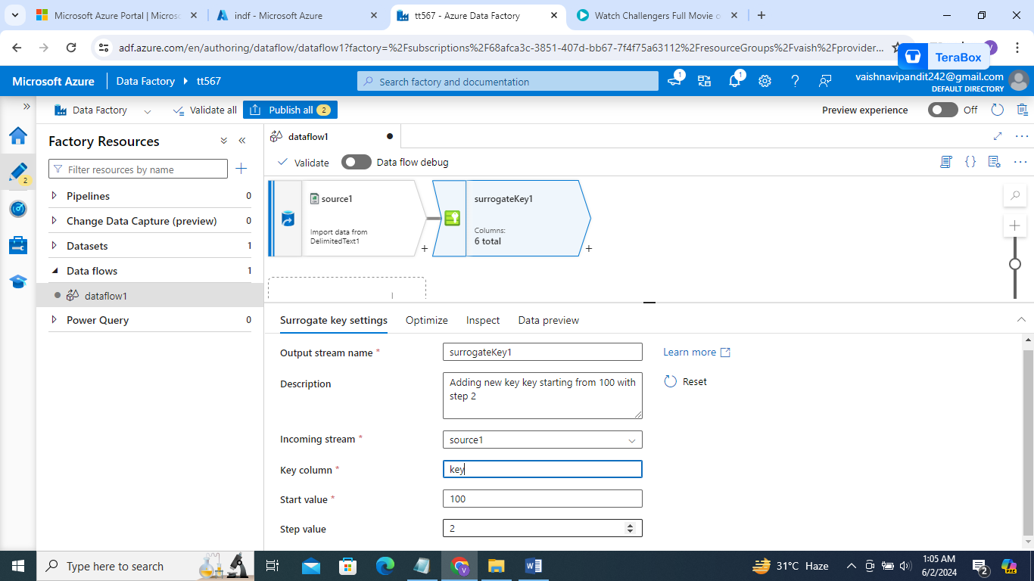

1. Go see preview

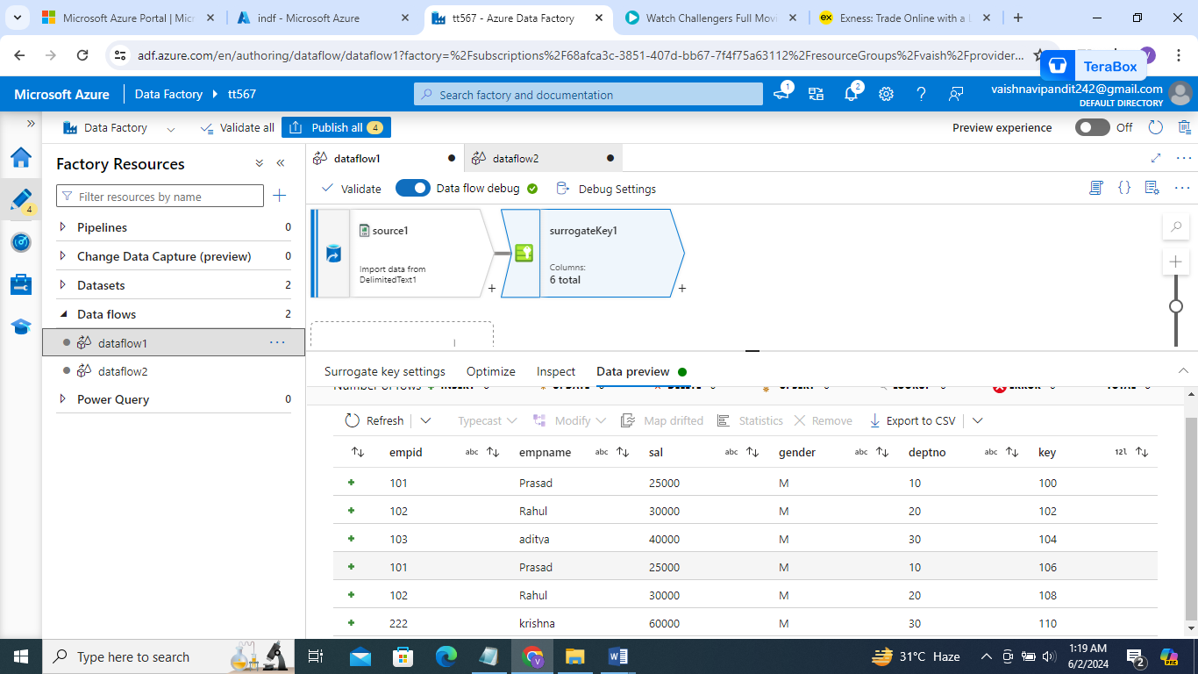

Finally the keys aare generated